Class Project Phase III - Part 1 Submission
SunDevil Connect | Group 6 - Individual Contribution | Xu Yan

Architecture Explanation and Architecture Diagram [15 Points]

Selected Architecture: Layered Client-Side Architecture
For the SunDevil Connect implementation, I selected a layered client-side architecture. The application is organized into a presentation layer, a coordination layer, a business logic layer, and a domain data layer. The presentation layer contains the Student view, Club Leader dashboard, and Admin panel. These screens collect input and display event, club, membership, and moderation information. The coordination layer is represented by the SunDevilConnectFacade, which gives the UI a simple set of methods for browsing events, registering for events, joining clubs, and executing dashboard commands. The business logic layer contains AuthController, EventController, ClubController, and AdminController. These controllers enforce the main rules of the system. The domain layer contains the main entities, including User, Student, Club, Event, ClubMembership, EventRegistration, Announcement, and FlaggedContent.
This architecture is a good fit for the current implementation because the project is a prototype that must demonstrate the complete workflow without requiring a deployed backend. It still preserves separation of concerns, so the system does not become one large script. The facade keeps the UI independent from controller details. The controllers keep business rules away from the HTML. The entity objects and data store make the application state easy to understand and modify. The implementation also applies two Phase II patterns directly: the State Pattern controls event lifecycle behavior, and the Command Pattern handles leader/admin actions such as creating events, approving memberships, posting announcements, and reviewing flagged content.

Comparison With Alternative Architecture
One alternative would be a simple monolithic front-end script where every button directly changes global arrays and page elements. That approach would be faster for a very small demo, but it would become difficult to maintain as soon as more roles and workflows are added. For example, student registration rules, club approval rules, event capacity rules, and flagged content moderation would all become mixed with DOM manipulation. Another alternative would be a microservices architecture with separate services for users, events, clubs, and moderation. Microservices could support a large production system, but they would add unnecessary deployment and integration complexity for this course increment.
The layered client-side architecture is better for this phase because it is realistic enough to show solid design while still being feasible for an individual implementation. It supports incremental growth: the current in-memory data store could later be replaced with a database-backed API while keeping the same UI and facade methods. This makes the architecture maintainable, testable, and appropriate for the Phase III implementation schedule.

C4 Context Diagram
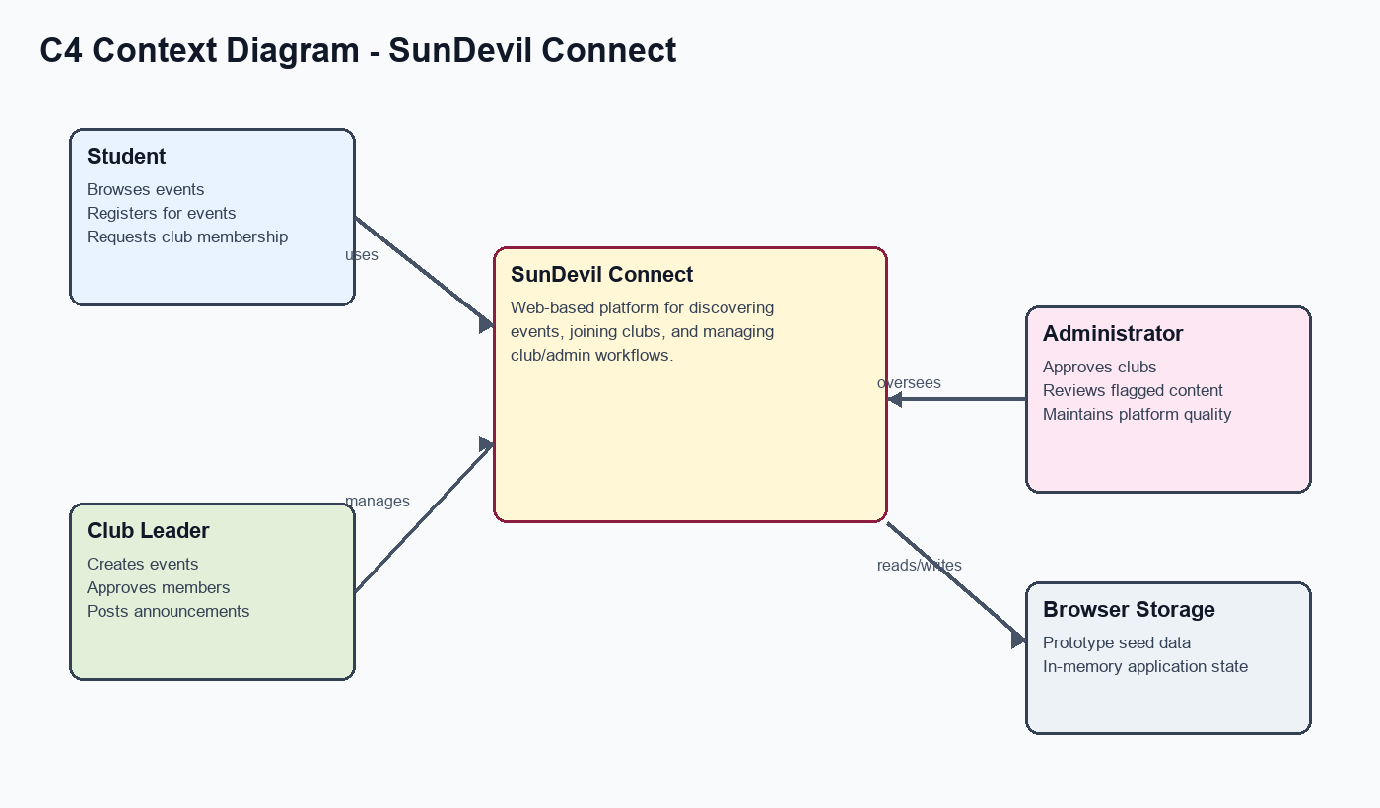
The context diagram shows the three main external actors: Student, Club Leader, and Administrator. Each actor interacts with SunDevil Connect through the browser-based application. The prototype stores seeded data and user actions in browser application state.

C4 Component Diagram
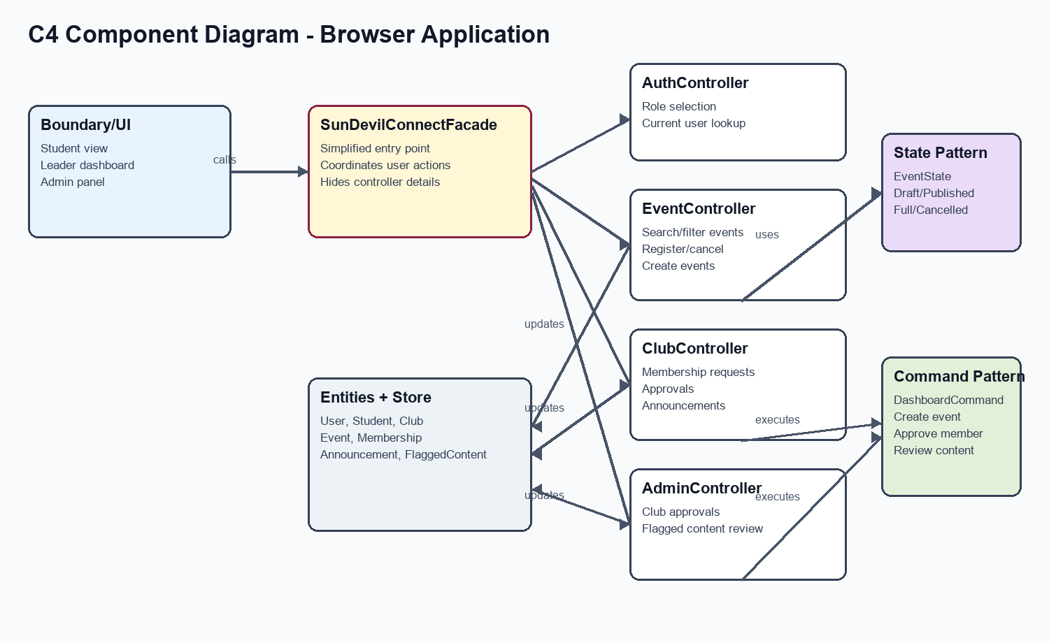
The component diagram shows how UI pages communicate with the SunDevilConnectFacade. The facade coordinates the controllers, and the controllers update domain entities and application state. EventState classes handle event status behavior, while DashboardCommand classes encapsulate dashboard operations.

Phase III Part 1 Code [10 Points]
Code folder prepared for upload:
- /Users/yanxu/Downloads/CSE 460 Project/Phase 3/SunDevilConnectApp
Google Drive link to paste after upload: [PASTE PHASE III PART 1 CODE LINK HERE]

Video Link [5 Points]
Prepare a 3-5 minute video explaining the architecture and demonstrating the student-side implementation: event browsing, filtering, event registration, and club membership request.
Video link to paste after upload: [PASTE PHASE III PART 1 VIDEO LINK HERE]

